   | Course Code | ITE6102
 | Description | Computer Programming 1
College / Department:  Online Education Department | Course Project | 001
COURSE PROJECT |  | Page 1 of 3

This activity will assess your knowledge and skills in applying C++ program in VS code that satisfies specific requirements to attain specific output.

Part 1:
- Create a video presentation from the topics listed below. Select one (1) group of topics only.
- The video must include an introduction, discussion of the topic, and sample program creation using Visual Studio Code for each topic (if possible).
- The video should include yourself presenting the topics. For the visual content, the student may use different materials and style (e.g. PowerPoint, live discussion, paper discussion). NOTE: Make sure that your face is clearly seen on the video as well as the display on the screen.

List of Topics:
Group 1
- Problem Solving Through Flowcharts 1 and 2
- Handling Primitive Data Types
- What about ifs
Group 2
- Through the Loops
- Dimensions of Data Types
- Introduction to Functions Procedures
Group 3
- Object-Oriented Programming 1 and 2
- It's All about Pointers and References 1 and 2

Part 2:
- Create a video that shows yourself doing the activity.
- The video should also show the screen of VS code as the program is coded.
- The output window should be seen in the video as data is entered and the corresponding output of the program is displayed.

Write a C++ program that will ask for the following input from the user:

Customer Name:
Age (should be 18 above):
Number of guests: (should be integer type)
Number of days: (should be double or float data type)

Determine the corresponding number of guests and rate per day as follows:

Number of guests | Daily Rate
1 | 1000
2 | 1,800
3 | 2,700
4 | 3,600
5 (and above) | 4,500

Compute the total payment as follows:
Total Payment = rate per day * no. of days
Down payment = 40% of the total payment
Balance = total payment – down payment

NOTE:
- Use your full name as customer’s name.
- User is not allowed to enter the age of 17 and below.
- Display an error message if the user enter an invalid value.

Assume that the user will not enter an invalid value.
Sample Input:
Customer Name: Juan Dela Cruz
Age: 25
Number of guests: 3
Number of days: 5
--------------------------------------------------------------------------------------------

Sample Output:
Hotel Reservation Slip
Customer Name : Juan Dela Cruz
Age : 25
Number of guests : 3
Number of days : 5
Total Payment : 13500
Down Payment : 5400
Balance : 8100

Instructions to submit the activity:
- Upload your video in YouTube or Vimeo then include the link together with the screenshots of your VS codes and program output in the space provided below.
- Save the activity file (Filename: LastnameFirstName- CourseProject_ITE6102.docx)
- Save the PowerPoint presentation (Filename: LastnameFirstName- CourseProject_ ITE6102.ppt)
- Compress these files (.docx and .ppt) in one folder and save it as .rar/.zip file.
(Example: DelaCruzJuan-CourseProject_ ITE6102.rar)
- Upload the .rar/.zip file on the submission page of the Course Project in the LMS.

Paste the Link of the Video recording here
https://youtu.be/zVELd2pMjXQ

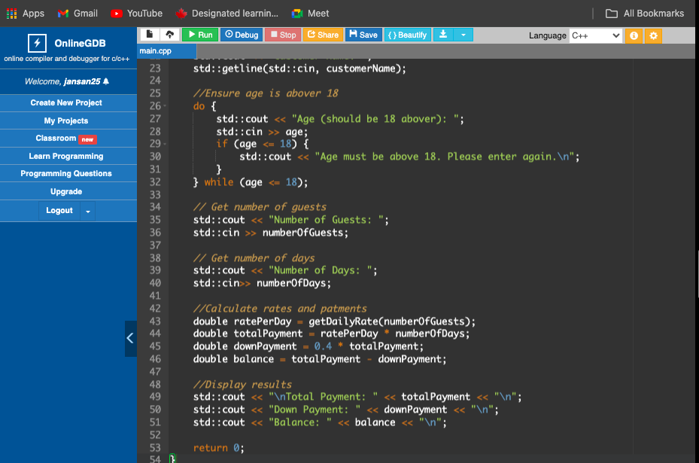
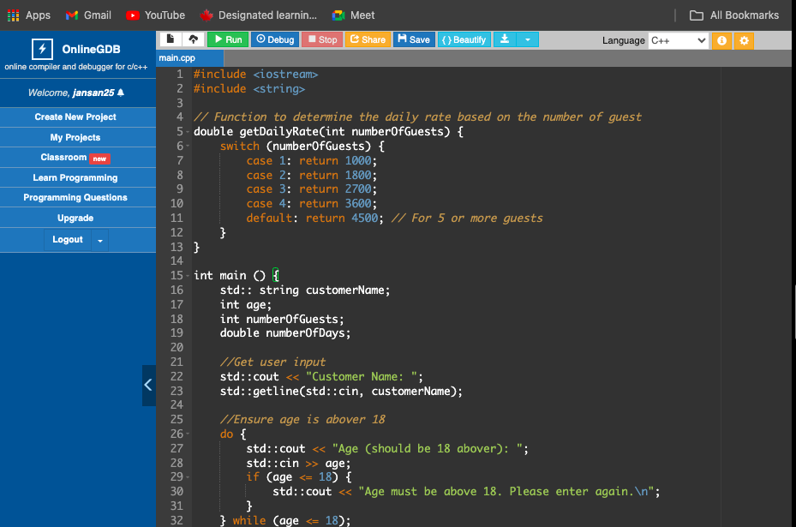
Attach the screenshots of the codes here:

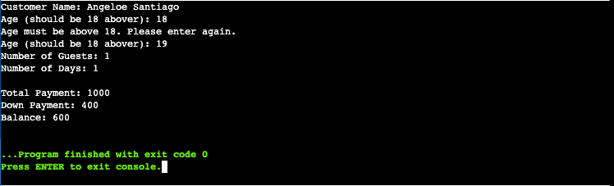
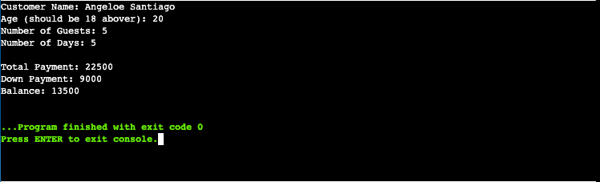
Attach the screenshot/s of the program output here:

NOTE: Incomplete submission will not be accepted and will be required for resubmission. The highest grade for the resubmission is 50.

-----------------------------------------------Good luck!!!! -------------------------------------------------

